

GRADE 11
NOVEMBER EXAMINATION 2013
HISTORY
PAPER 2 (SOURCE PAPER)
3 hours 200 marks

INSTRUCTIONS:
This paper consists of 14 pages
There are THREE sections in this exam
- SECTION A – Question 1-3-Individual Source Analysis (60)
- SECTION B – Question 4-Source Based Question (90)
- SECTION C – Question 5-Source Based Essay (50)
You are to answer all the questions in the book provided.
Make sure your answers are correctly numbered and clearly written. Write on both sides of the page.
Accurate and adequate factual knowledge is essential; equally important in answering the questions is the ability to use relevant information critically.
Time yourself and do not spend too much time on one question and too little on another.
When you have finished your exam put your question paper at the back of the answer book.

EXAMINER: MRS J-A MOGG MODERATOR: MRS A LOURENCO

SECTION A INDIVIDUAL SOURCE ANALYSIS QUESTIONS

QUESTION 1 SOUTH AFRICA IN THE 1990s

This question will focus on your ability to read, comprehend, analyse and evaluate a photograph.
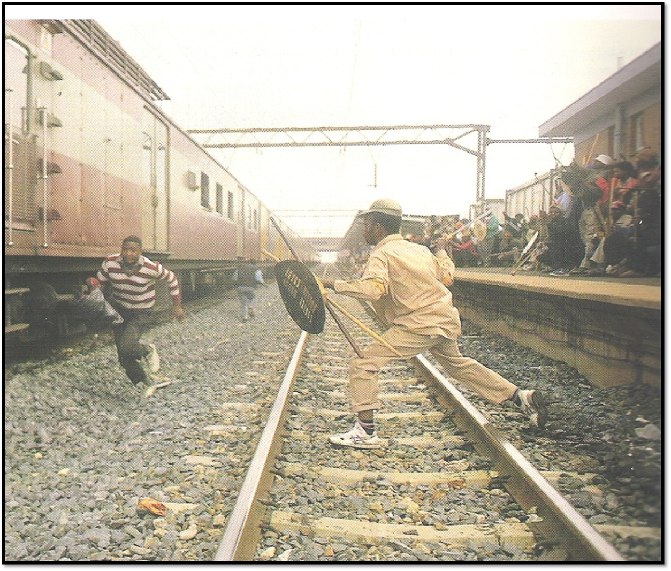
Photograph of the “Train violence” in SA during the early part of the 1990s
- Using visual clues from the source describe what is happening in the photograph. (4)

- What impact would this photograph have had on:
The White population in SA? (4)
The International community (4)

- Who would have taken photographs like this and for what purpose? (4)
20 marks

PLEASE TURN THE PAGE
QUESTION 2 SOUTH AFRICA IN THE 1990s

This question will focus on your ability to understand and analyse a textual source.

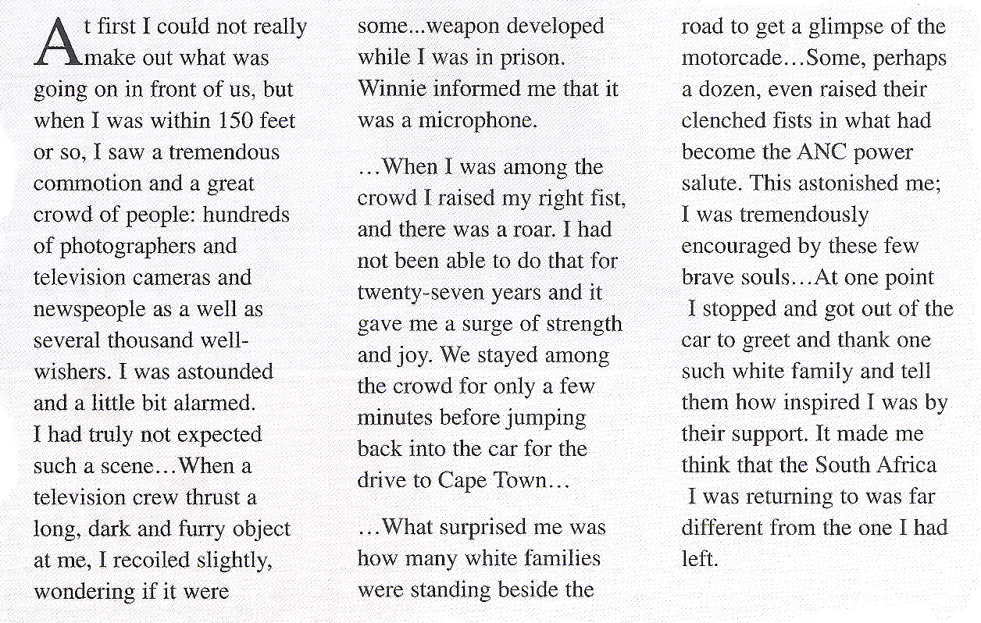
Nelson Mandela describing his first steps as a free man leaving Victor Verster prison in Paarl, in his autobiography, A Long Walk to Freedom, 1994

- How useful is this source in providing information about the effect of Mandela’s release? Explain using quotes from the source. (6)

- What is the significance of a “raised right fist” as described by Mandela in the second paragraph? (4)

- Why would Mandela have been taken aback by the number of white people who came out to greet him? (4)

- What can you learn about Mandela’s personality from this source? (3)

- After reading this source what effect do you think Mandela could have had on creating a unified South Africa? (3)

20 marks
QUESTION 3 THE TRC

This question will focus on your ability to understand and analyse a cartoon.

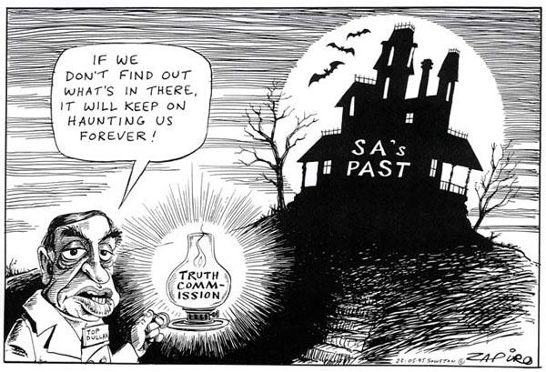
A Zapiro cartoon, Dullah Omar and the haunted house cartoon, May 23, 1995

- What is the message that Zapiro is trying to convey? (4)

- Describe how Zapiro uses two visual images in the cartoon to convey his message. (6)

- Do you agree with Dullah Omar’s comment that “if we don’t find out what’s in there, it will keep on haunting us forever?” Explain your answer. (6)

- Cartoons contain powerful messages, however they are limited. Explain why an historian would find this a limited source on the TRC. (4)

20 marks
PLEASE TURN THE PAGE
SOUTH AFRICA : THE ROAD TO DEMOCRACY IN THE 1990’S

Source A
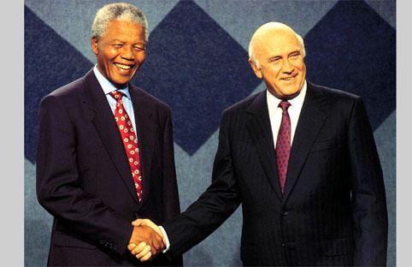
Nelson Mandela and FW de Klerk, JohannesburgPaul Velasco Photography www.picturenet.co.za
http://www.picturenet.co.za/photographers/pv/web/people01.JPG

Source B
It seemed that the unbanning of political organizations and the release of Mandela and the others had lit a fire under South Africa. A huge pot was beginning to cook and it looked like it might boil over. There were a lot of ingredients in the pot – moderate white people who were worried about losing their comfortable lifestyle, radical white nationalists who were determined not to accept majority rule, black radicals who thought that the only way to gain freedom was to drive white people out of the country, Zulu nationalists who were set on having power in their own part of the country and many others.
Whenever there was a bit of progress in the negotiations, there seemed to be another riot or massacre somewhere in the country. Often, there were reports that the police or army, were either helping the violenceto happen, or not doing anything about it when they could. The pot got hotter.

K. Pampallis, Mandela,Maskew Miller Longman, 200 p.61

PLEASE TURN THE PAGE

Source C
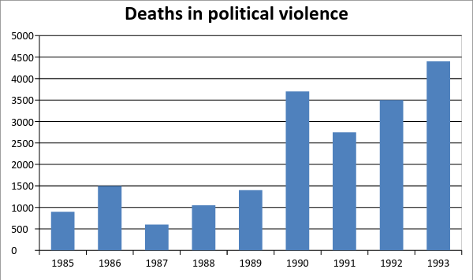
Deaths caused by political violence in South Africa, 1985-1993
(Source: South Africa 1948-94, by Martin Roberts, Longman, 1996)

Source D
The Negotiated Revolution: Society and Politics in Post-Apartheid South Africa, by Heribert Adam and Kogila Moodle, Johannesburg, Jonathan Ball 1993
Regardless of peace accords signed at the top [by political leaders], antagonistic groups at the bottom often act violently, independent of leadership controls. Such behavior has in particular, been undertaken by elements of the official security establishment, linked to right –wing agendas of destabilizing the negotiation.

PLEASE TURN THE PAGE

Source E
A major in the Bureau of State Security (BOSS) outlines the government’s tactical approach to the violence:
The government decided that black on black violence should be one of the strategies and a confrontation between Zulu’s and Xhosas should be encouraged because the two ethnic groups were the largest in the country. The army recruited people, especially youths, from outside South Africa, mainly rebel soldiers – trained them and sent them to protect compounds and start violence. They were trained to destabilize communities. The strategy was aimed at weakening the ANC and promoting Inkatha in its place.

Quoted in: South Africa since 1948, by Chris Culpin, Hodder Murray, 2000

Source F
In March 1992 de Klerk won referendum among whites over whether he should continue with the negotiations. A further meeting of Codesa in 1992 broke down… the ANC, already angered by what it said was de Klerk’s failure to stop the violence broke off further negotiations when a particularly brutal and large massacre occurred at Boiphatong, a township south of Johannesburg. Inkatha supporters from a nearby hostel ram amuck among residents of a squatter settlement. The ANC then embarked on a campaign of ‘rolling mass action’ to put pressure on the government to act to stamp out the violence.

Looking into the Past 12, YonahSeleti et al., Maskew Miller Longman, 1999

PLEASE TURN THE PAGE

Source G

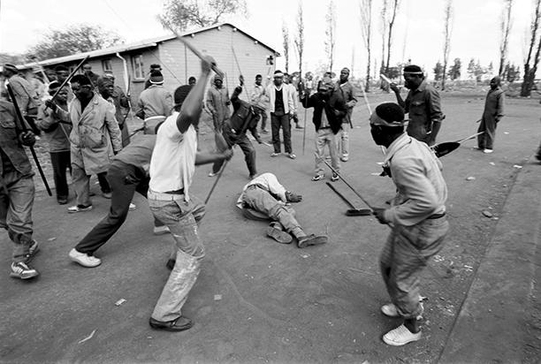
Greg Marinovich, born in South Africa in 1962, Greg, is a Pulitzer Prize-winning photographer who documented South Africa’s transition to democracy. He is the co-author of the book The Bang Bang Club that the movie was based on. Photo taken in the early 1990s

PLEASE TURN THE PAGE

Source H
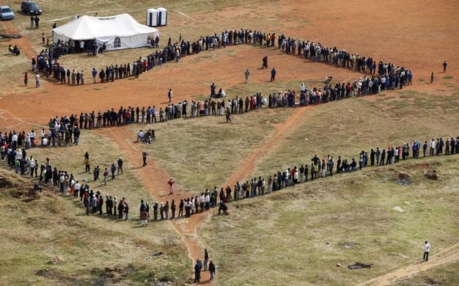
Great lines of patient people snaking through the dirt roads of towns and cities, old women who had waited half a century to cast their vote, saying they had felt like human beings for the first time in their lives, White men and women saying they were proud to live in a free country at last ... it was as though we were a nation reborn.
- Nelson Mandela, Long Walk to Freedom. London: Abacus, 1994, p.743
Source I
Thlokie Mofokeng, a resident of Soweto, explains the attitude of the PAC and AZAPO towards the negotiations:
They did not condemn Mandela but they were very much against negotiations. They tried to make people believe that Mandela was a genuine political leader but he was unfortunately, surrounded by the ANC which was too influenced by whites. They also said that the very people who own the land cannot help distribute it. They said ”You cannot negotiate to take back something that is yours. You must just take what belongs to you.”

Oxford Exam Success, Study Guide,2007,Jean Bottaro and PippaVisser,Oxford University Press

Source J
An extract from Nelson Mandela’s speech to the nation on the assassination of Chris Hani, in April 1993, by a white, right –wing extremist:
We are a nation in mourning. Our pain and anger is real. Yet we must not permit ourselves to be provoked by those who seek to deny us the very freedom Chris Hani gave his life for. Let us respond with dignity and in a disciplined fashion….

Quoted in : Looking into the past Grade 12, YonahSeleti et al., Maskew Miller Longman

PLEASE TURN THE PAGE

SECTION B: SOURCE-BASED QUESTIONS
Study the sources and answer the following questions
Refer to Source A
- What political positions did FW de Klerk, and Nelson Mandela hold in early 1990? (2)
- Why would a photo like this have been taken? (5)
Refer to Source B
- Briefly define the following historical terms
  - Moderate (2)
  - Radical (2)
  - Nationalist (2)
- Using your own knowledge name:
  - A radical white group (2)
  - A radical black group (2)
  - The party that the Zulu nationalists supported (2)
- According to Source B, what threatened democracy in South Africa in the early 1990’s? (4)
Refer to Source C
- What comparison can you make regarding the level of political violence in South Africa between the 1980’s and the 1990’s? (4)
- To what extent do you think statistics for political violence in those years can be regarded as reliable? Explain your answer. (5)

PLEASE TURN THE PAGE

Refer to Sources D and E
- How does source D suggest the leaders attempted to keep the peace? (4)
- What two reasons does source D suggest to account for the continued violence? (4)
- How does Source E support Source D’s explanation for the continuing violence? (5)
- Source E claims that the government’s strategy was aimed at ‘weakening the ANC’. What purpose would this have achieved? (4)
Refer to Source F
- According to the information in Source F decide whether the following statements are TRUE OR FALSE. (You do not need to explain your answer)
12.1 A referendum is a general vote by the electorate on a single political question that has been referred to them for a direct decision. (2)
12.2 FW de Klerk did not have the support of the white electorate. (2)
12.3 The ANC withdrew from Codesa 1 as a consequence of the Boiphatong massacre. (2)
12.4 The ANC believed that it was the Government’s responsibility to curb the violence. (2)
12.5 Source F is not a useful source for historians studying the breakdown in the negotiation process in the 1990’s. (2)
Refer to Source G
13.1 Using the source and background knowledge explain why there was so much violence in South Africa in the early 1990s. (5)
13.2 Why would you consider this photograph unreliable? (5)

PLEASE TURN THE PAGE

Refer to Source H
14.1 Explain what Mandela means in the extract. (4)
14.2 What impression does the photograph give you of the first democratic elections in South Africa? (2)
14.3 Why do you think the statement and the photograph came as a surprise to a lot of people? (3)
14.4 What made the event in the scenario in the photo possible? (3)
Refer to Source J
15. Who was Chris Hani and what role did he play in the negotiation process? (3)
16. What impact was Mandela’s speech meant to have on South Africans at that time? Explain, with reference to the speech’s text (6)

[90 Marks]

PLEASE TURN THE PAGE

SECTION B SOURCE BASED ESSAY
In this section of the paper, you will use all the sources to extract relevant information to answer a question.
You will be expected to:
Identify the relevant information from each source and reference the sources.
Group the sources and use them to back up what you are saying.
Do not use the ‘shopping list method’.
Take a definite stand on the question.
Build a logical argument or discussion.
Acknowledge a counter argument, if there is one.
Communicate your answer clearly.

“South Africa’s transition to democracy is often referred to as a ‘peaceful’ one.”
How far do the sources agree with this statement?
[50 marks]

